WOMEN’S LAND RIGHT IN THE AGRICULTURE VALUE CHAIN DEVELOPMENT PROJECT (AVDP) SIERRA LEONE – CASE STUDY
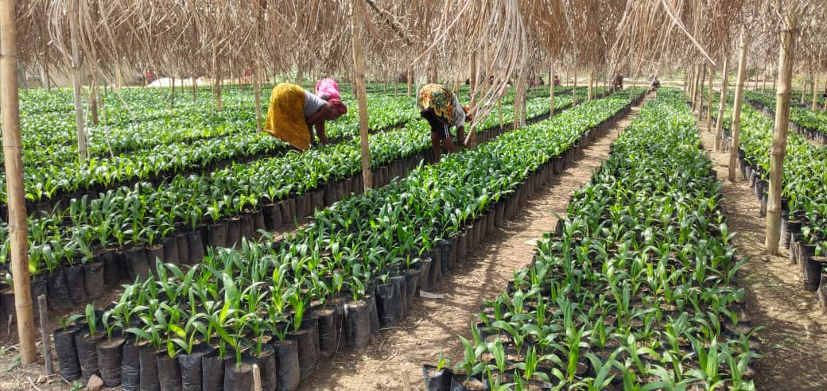

GENDER YOUTH TARGETING AND NUTRITION UNIT (AVDP)
SEPTEMBER 2022

INTRODUCTION

Gender mainstreaming is an integration of gender concerns into policies, plans, programmes and legislations. The goal of gender mainstreaming is gender equality. The Government of Sierra Leone is committed to gender mainstreaming and successive governments have translated these commitments into concrete actions. Sierra Leone is a signatory to so many International, Regional, and sub-regional frameworks for the promotion of gender equality and the empowerment of women
There is consistent and credible evidence that the status of women is improved, agricultural production and productivity increases, poverty is reduced, and credible evidence and nutrition improves. In Sierra Leone, 70 percent of the agricultural labour force represents women, playing a critical role in natural resource management and food cultivation. Contributions of Sierra Leone women in agriculture deprived, discriminated against ownership, access, and control of the land. Most importantly, women do not realize their economic impact on their agricultural activities. This is because the customary and statutory laws which favours men as against women in our society.
Focusing on the increased-on gender equality in production and productivity systems can transform agricultural livelihoods, improve development outcomes, and make institutional cultures more enabling. Gender approach as a crosscutting element in all IFAD’s development interventions in any developing country, the newly funded Agricultural Value Chain Development Project (AVDP) in Sierra Leone is no exception.
The AVDP a six-year project from 2019 to date, and already been implemented for three years, it’s overall project goal is improving livelihoods, food security and climate change resilience of rural farming households in Sierra Leone. The Project Development Objective is to increase incomes for smallholder farmers through the promotion of
agriculture as a business. The project development objective and approach are aligned with the two strategic objectives of the Country Strategy. Over the life of the project, AVDP target and estimated 43,000 direct beneficiary households, thereby reaching approximately a total of 258,000 people. AVDP interventions include at least 40% women and 40% youths inclusive with people with different disabilities (PwDs) and employed mechanisms that promote gender equality and social inclusion. The Project employed participatory approach the Gender Action Learning System (GALS) and pay attention to the inclusion of those most vulnerable.
Gender Action Learning System (GALS) is a community-led empowerment methodology which aims to give women as well as men more control over their lives and catalyze and support a sustainable movement for gender justice. A key focus is changing gender inequalities within the family and community as challenges which prevent both women and men at all levels from achieving their vision. The participatory process develops practical and sustainable guidelines which can be integrated into livelihoods, market, value chain development, financial services and decision-making.
Gender Balance Tree (GALS Tool) diagnose the extent to which the household have skewed division of labour and disproportionate distribution of benefit derived
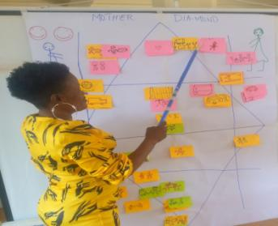
Land is a major factor in agriculture, most farming families have small fields to cultivate, and land fragmentation is common, limiting production and productivity and agricultural transformation as well as gender equality opportunities. Most women in Sierra Leone are based in rural areas and make living from the land. Land ownership is one of the key limiting factors of production among female farmers. Land access is one of the livelihood challenges associated access to land as it is about obtaining means to use the land in rural Sierra Leone. Land ownership, land access is severely curtailed by the way land is inherited and owned in most patrilineal rural communities.
Land belongs to the community or government and individuals under the community system of farmland ownership. For use of it acquire permission from local authority, most of the cases, women can be given the right to use land if they obtain the consent of the husband. The customary system provides for private ownership, but the land belongs to the family and is most often administered by the male head of the household. A married woman under the customary marriage rules, women cannot manage a couple’s property nor make economic decisions
COUNTRY POLICY DEVELOPED TO IMPROVE WOMEN’S LAND USE IN SIERRA LEONE
2015 the Ministry of Land Planning and Environment developed a National Land Policy of Sierra Leone, and the policy objective is to promote equitable access to land by:
a) Ensuring equitable access to lands for all citizens regardless of sex or sexuality, race, colour, language, religion or conviction, political or other opinion, social origin, ethnicity, age, economic position, ownership of property, a marital status disability, birth or other status
- Gender equality principles in the National Land Policy (NLP) ensure equal rights of women and men in the enjoyment of all human rights, acknowledge differences between women and men and shall take specific measures to accelerate de facto equality where discrimination exists.
- The NLP ensure equal tenure rights and access to land for women and girls independent of their civil or marital status
- The NLP ensure the repeal, modification or elimination of all laws, policies, customs, and practices that discriminate on the basis of gender
In 2019, the Food and Agriculture Organization (FAO) of the United Nations with the International Labour Organization (ILO), in collaboration with the Government of Sierra Leone with support from the Peace building Fund (PBF) conducted a workshop on Gender and Land Rights, the objectives was to enhanced the capacities of Traditional Authorities (especially Paramount Chiefs, Section Chiefs, and Mamie Queens) to better understand and advocate for Peace-building mechanisms and promoting Women’s Land and property rights in their communities

2021, the Ministry of Land and Housing and Country Planning introduce the “Customary Land Right Act 2021” and “National Land Commission Act 2021”. The Customary Land Rights Act, is to promote tenure security, and support access to land without any form of tribal, religion, gender, or other forms of discrimination

2021, Gender Equality and Women’s Empowerment (GEWE) Policy developed and approved by the Government of Sierra Leone, which the policy’s overall goal is to mainstream gender into all the national, sectoral, and local policies, plans, budgets and programmes, to achieve GEWE in all spheres of development in Sierra Leone, control over productive resources to lessen poverty among women in Sierra Leone by 2025.
AVDP STRATEGY FOR WOMEN LAND OWNERSHIP AND ACHIEVEMENT TO DATE
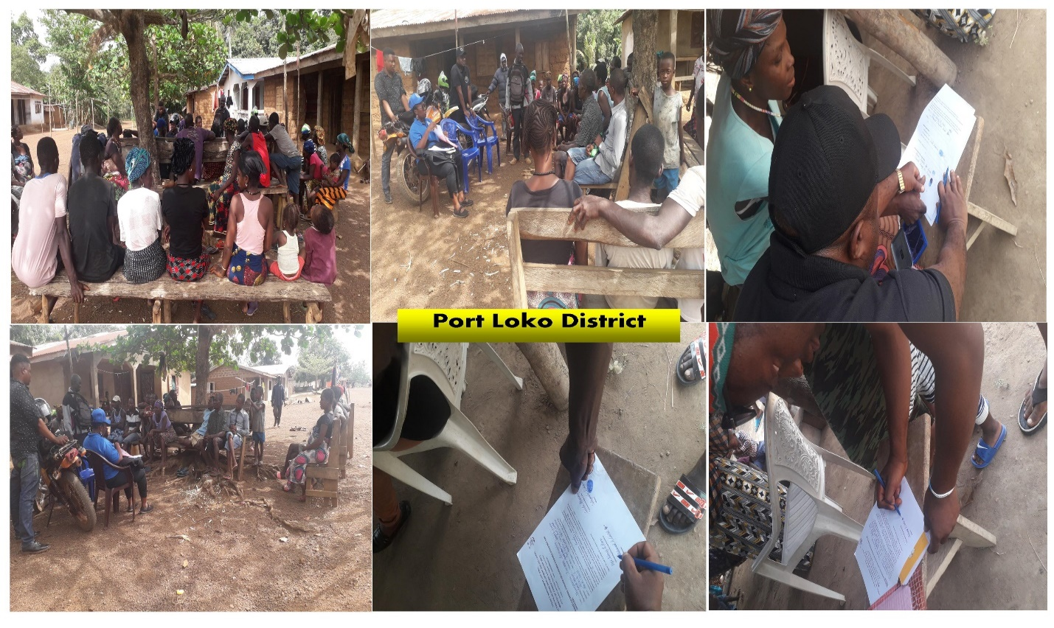
Community Engagement with Authorities and tree crops beneficiaries on women land ownership

As mentioned in the gender targeting at project design, the gender gaps in agriculture stated are.
Women’s land rights problems. They cannot inherit or have right to land. They have less access than men to land, control over it, and land tenure security, resulting in less ability to invest in agriculture and expand beyond subsistence level

In the AVDP intervention in tree crops (cocoa and oil palm), land problems for women have improved, from initial inception of the project, a dialogue session with land ownership was part of the package for a community to benefit from any of the interventions. This was clearly stated in the beneficiary selection and profiling as criteria set by the project for stakeholders and landowners to provide land for women.

So far, the beneficiary of the project selected and profiled for the sex years intervention in the value chain crops (rice, oil palm, cocoa, and vegetable) shows 54% women beneficiaries to be supported in all project activities.
From 2019-2021 cocoa and oil palm targeted 4,500 household beneficiaries total of 4,500 hectares, and 2,247 Women households benefited 49.9% total of 2,247 hectares, 01 hectare per household.
Table showing women beneficiaries supported with cocoa and oil palm seedlings during the three years implementation.
Intervention | Year | Target  Beneficiary | Women beneficiary | %
Oil Palm | 2019-2021 | 3,000 | 1,524 | 51
Cocoa | 2019-2021 | 1,500 | 723 | 48
Oil palm and cocoa Women land Owers |  | 4,500 | 2,247 | 49.9
Source: M&E Unit Database

At present women beneficiaries for cocoa and oil palm have signed land agreement document by landowners and signatories of key stakeholders (Landowners, Director District Agriculture Office, Town Chief or any other higher Authority) in the locality for permanent ownership by the women for their 01hectare of cocoa or oil palm farm.

Land agreement document signed for each of the AVDP women beneficiaries in their own names, not their spouse’s name. Each of the women cocoa and oil palm beneficiaries completed out planting and now taking full control of their plantations, some paid labour for most of the activities of the cocoa or oil palm production.
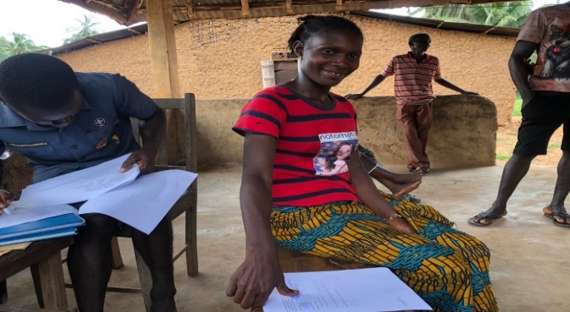
Signing land agreement document

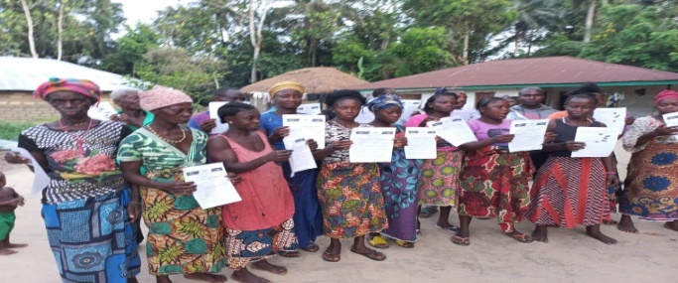
Oil palm and Cocoa Women beneficiaries singed land agreement docurements
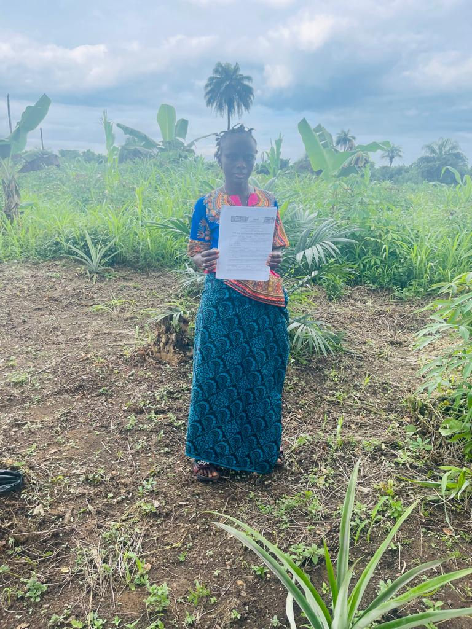
ZAINAB LAMBOI, a female oil palm youth contractor and beneficiary, age 28 years from Talia community, Kakua Chiefdom, Bo District, Southern Region of Sierra Leone. She dropped out of School at primary level and married with two children. Her main occupation is farming, she was fortunate to be selected as one of the youth contractor for the oil palm community nursery establishment and management of 540,000 oil palm seedling for a period of six months.

Zainab benefited with 01hectare of oil palm seedlings, and out planting of these seedlings are completed. She is presently standing in her 01 hectare oil palm plantation, which she practices climate smart cultivation. The oil palm is intercropped with plantain, pineapple suckers, cassava cuttings. At presently preparing to inter cropped with groundnut.

HOW ZAINAB ACQUIRES THE LAND
ZAINAB LAMBOI, TALIA, KAKUA CHIEFDOM, BO DISTRICT, SOUTHERN REGION
AVDP entry into our community to select and profiled 30 household beneficiaries for cultivation of 30 hectares of oil palm, was a big blessing for me. Out of the 30 members, 15 of us are female, criteria set by the project, land available for women by community authorities, 40% women out of the 30 members are key criteria for a community to benefit from tree crops support.

I acquired my 01 hectare of land through my husband’s family. AVDP requested for a climate smart demonstration plot for farmer field school field practices, I was fortunate to provide my own land for the demo-plot.
Husband engaged his family and requested for 01 hectare of land to be offer freely to me permanently, and his family agreed and allocate the land, by signing a land agreement document in my own name.

IMPACT

She has been economically empowered benefiting and owning 01 hectare oil palm plantation, with a signed land document,

receiving monthly stipend as a youth contractor, benefiting from training allowances.

The project built her capacity through workshops, and farmer field school phases. Attending a workshop on oil palm nursery establishment and management, Gender Action Learning System (GALS), and farm field school in oil palm nursery establishment, management and out planting at first phase. She will be capacitated in the second phase of the farmer field school in the oil palm field management, processing and marketing, and graduation.

Physically empowered, as a youth contractor, she cascaded the farmer field schools learning to her own farm and participated in plotting the farms of all the other beneficiaries within their community.
The Climate Smart practices is another economic benefit, she is happy of. Her plantation used as the demo-site intercropped the oil palm with plantain, pineapple suckers, cassava cutting and groundnut. All these crops are short variation, which will be harvested soon. The plan for her proceeds income of the crops intercropped are paying labour for under brushing, children school fees and home consumption.

Decision-making concerning her farming activities is done by herself, and later inform her spouse. She clearly stated, most of the activities at home and farm are done by both, The gender dynamics is manifested as both share power in the household, leading to a fair distribution of workload both at the household and in productive activities.

CHALLENGES ALONG THE WAY
- Human theft of proceeds from the farm as the location of the farm is on the vehicle road leading to the village
- Drudgery during harvesting
- Processing facilities
- Ready market

LESSONS LEARNED
- Women accessing, owning of land and plantation, this have started empowering women to own a tangible assets
- The farmer field school approach made an effective extension service delivery to women beneficiaries

SUCCESS STORIES
- The land lease agreement process provided an opportunity for resolving domestic conflict especially between couples
- The legal status of the land for the cocoa and oil palm out planting established through the signing of land lease agreement between women by community authorities/landowners.
- Achieving, and exceeding the project outreach target of 54% women, against project target of 40% women.

RECOMMENDATIONS

- Land signing agreement documentation be upscale to the balance target of oil palm and cocoa women beneficiaries
- Farmer field school approach continuation to bridge the gap of women extension service challenges
- Upscaling the GALS and Nutrition Education training to AVDP target beneficiaries, to address gender norms, and nutrition issues.
- Effective field monitoring for community engagement on targeting requirement, gender issues etc.

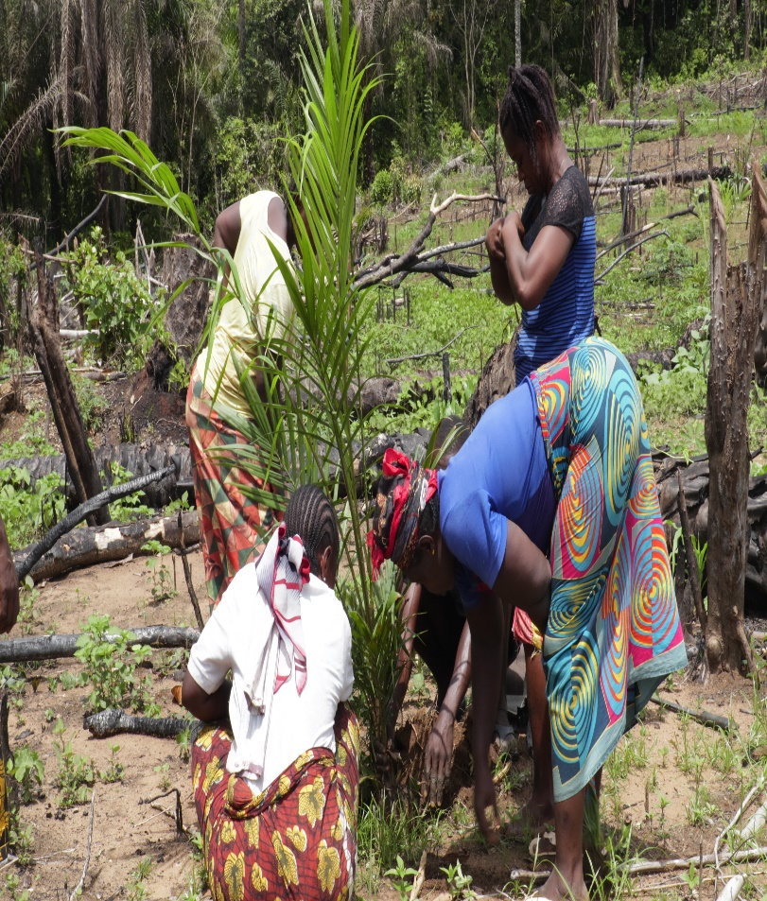
OIL PALM OUTPLANING TO PERMANENT FARM OF WOMAN BENEFICIRY

FAO UN; 1st November 2018

